Georgia and Bob decide to play a self-invented game. They draw a row of grids on paper, number the grids from left to right by 1, 2, 3, ..., and place N chessmen on different grids, as shown in the following figure for example:

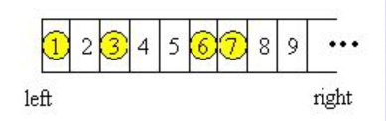

Georgia and Bob move the chessmen in turn. Every time a player will choose a chessman, and move it to the left without going over any other chessmen or across the left edge. The player can freely choose number of steps the chessman moves, with the constraint that the chessman must be moved at least ONE step and one grid can at most contains ONE single chessman. The player who cannot make a move loses the game.   
  
Georgia always plays first since "Lady first". Suppose that Georgia and Bob both do their best in the game, i.e., if one of them knows a way to win the game, he or she will be able to carry it out.   
  
Given the initial positions of the n chessmen, can you predict who will finally win the game?

Input

The first line of the input contains a single integer T (1 <= T <= 20), the number of test cases. Then T cases follow. Each test case contains two lines. The first line consists of one integer N (1 <= N <= 1000), indicating the number of chessmen. The second line contains N different integers P1, P2 ... Pn (1 <= Pi <= 10000), which are the initial positions of the n chessmen.

Output

For each test case, prints a single line, "Georgia will win", if Georgia will win the game; "Bob will win", if Bob will win the game; otherwise 'Not sure'.

Sample Input

2

3

1 2 3

8

1 5 6 7 9 12 14 17

Sample Output

Bob will win

Georgia will win

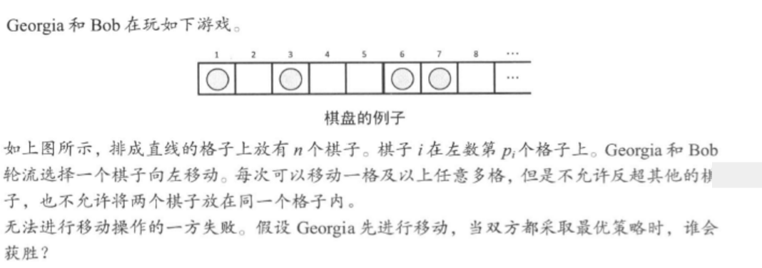

思路：很巧妙的转化为Nim游戏，首先相邻的两个作为1组，如果是奇数，就第一个和0作为1组，然后如果移动每组的前一个棋子，其实是没有影响的，因为后手可以跟他一样，把后面的棋子移动一样的步数，而移动后手，相当于把一个区间缩短，这样一个区间的长度就等同于Nim游戏中石子的数量，转化为了Nim游戏

先将数一一配对（a,b)，若是奇数则把最左边与0配对。

那么若对方向左挪a，我们也挪动b相同步数。

那么唯一会影响的就是各配对间的间隔。

假设有间隔c1,c2..cn

那么相当于每次选一个数，减去至少1.

这就像nim取石，有n堆石子，每次至少取走其中一堆的至少一个，谁最先没石子取就输。

这个问题的答案是 c1^c2^..^cn=0时有必输解，否则必胜。

#include <stdio.h>

#include<algorithm>

using namespace std;

int a[1010];

int main()

{

int t;

scanf("%d",&t);

while(t--)

{

int n,ans = 0,step;

scanf("%d",&n);

for(int i = 0 ; i < n ; i ++)

scanf("%d",&a[i]);

sort(a,a+n);

int t = 0;

if(n&1)//n是奇数

{

ans^=(a[0] - 1);

t++;

}

for(int i=t;i<n;i+=2)

ans^=(a[i+1]-a[i]-1);//将两球之间的空格看作一堆石子

if(ans) //不为0

printf("Georgia will win\n");

else

printf("Bob will win\n");

}

return 0;

}